**Homework 4**

**Submit: Blackboard/Paper Due: Nov. 16th**

**Please write down Your Name & Student ID**

1. Within tissue lies a strongly reflecting boundary, which backscatters 70% of the intensity of the ultrasound beam. Given a 100dB receiver dynamic range, and an operating frequency of 3 MHz, what is the maximum depth within tissue at which this boundary can be detected? (the frequency dependence of the attenuation coefficient for soft tissue is )
2. Calculate the distance at which the intensity of a 1 MHz and 5 MHz ultrasound beam will be reduced by half traveling through (a) bone, (b) air, and (c)muscle.(The attenuation coefficient for muscle, bone and air are , respectively )
3. Plot the transmitted frequency spectrum of an ultrasound beam from a transducer operating at a central frequency of 1.5 MHz Assume that the transducer is damped. Repeat the plot for the beam returning to the transducer after having passed through tissue and been backscattered.
4. (a) Show the required timing for simultaneous steering and dynamic focusing of a phased array. For simplicity, sketch the general scheme using a small number (for example five) of elements.

(b) Sketch the corresponding delays required for dynamic beam-forming during signal reception.

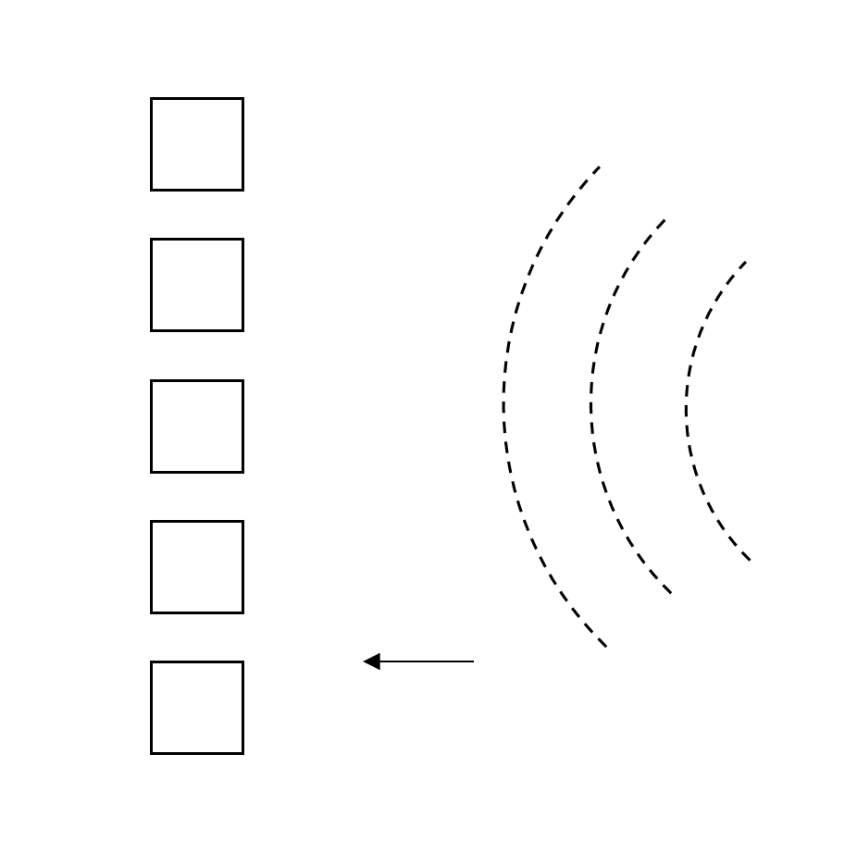

**Figure 4**

1. A B-mode scan is taken of the object in Figure 5 with a linear array. There are four tissue components, ***a*** and ***b*** with a boundary in-between and two spherical tumors ***c*** and ***d***. Given the corresponding ultrasound image shown on the 5.b what can you deduce about the acoustic characteristics of components ***a***, ***b***, ***c*** and ***d***?

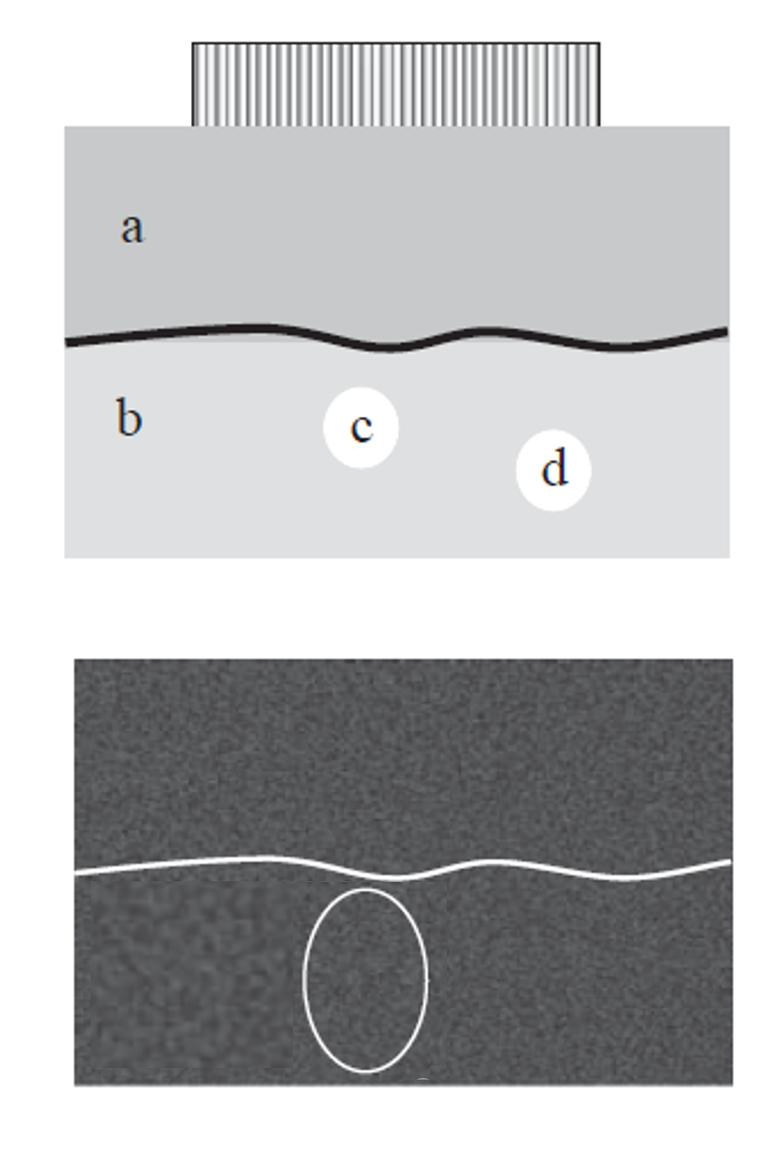

**Figure 5**

**(a)**

**(b)**

1. Doppler ultrasound is currently the preferred non-invasive carotid artery examination method. It can not only display the location and size of the plaque, the location and severity of the lumen stenosis, but also perform hemodynamic measurement and morphological evaluation of the plaque. Sketch the Doppler spectral patterns at points 1, 2, and 3 in a carotid artery shown in Figure 6. (All of the plots need be made over one cardiac cycle)

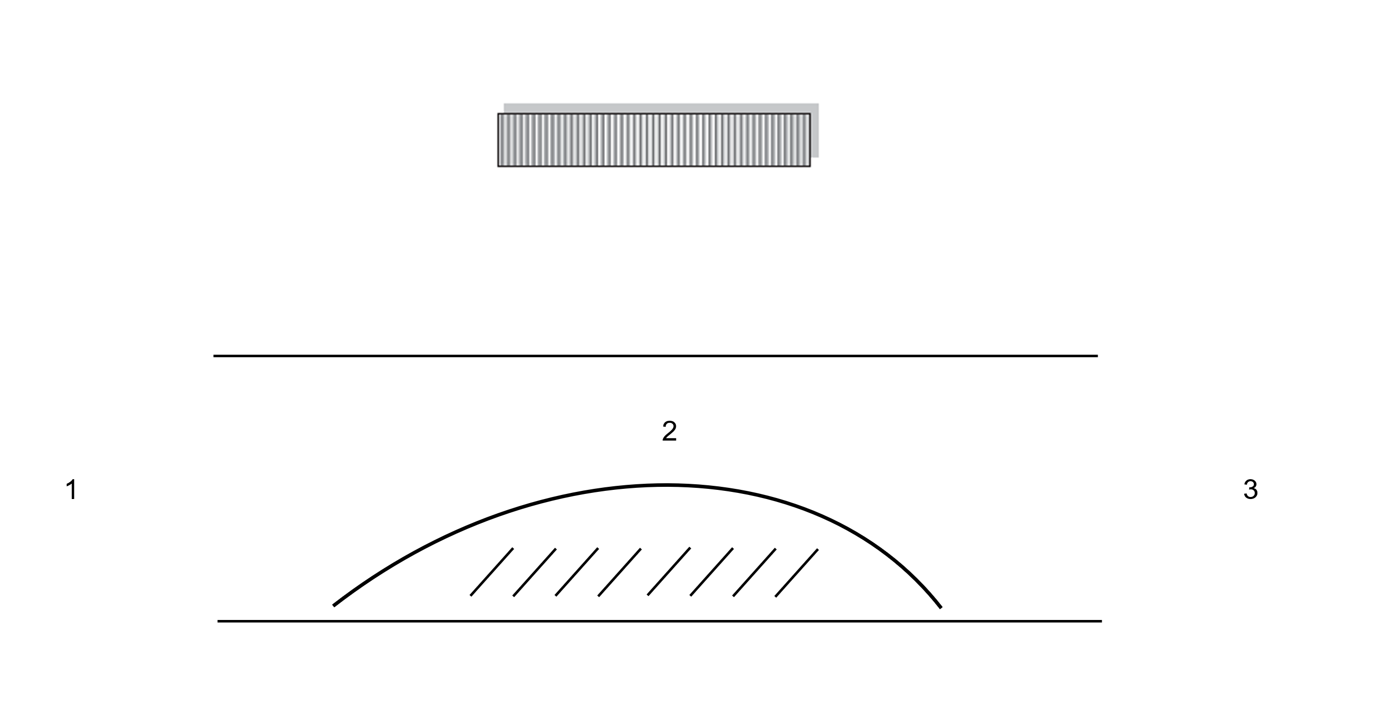

**Figure 6**